1. **Code**

<https://github.com/daizhaohui/abc-demo>

git clone <https://github.com/daizhaohui/abc-demo.git>

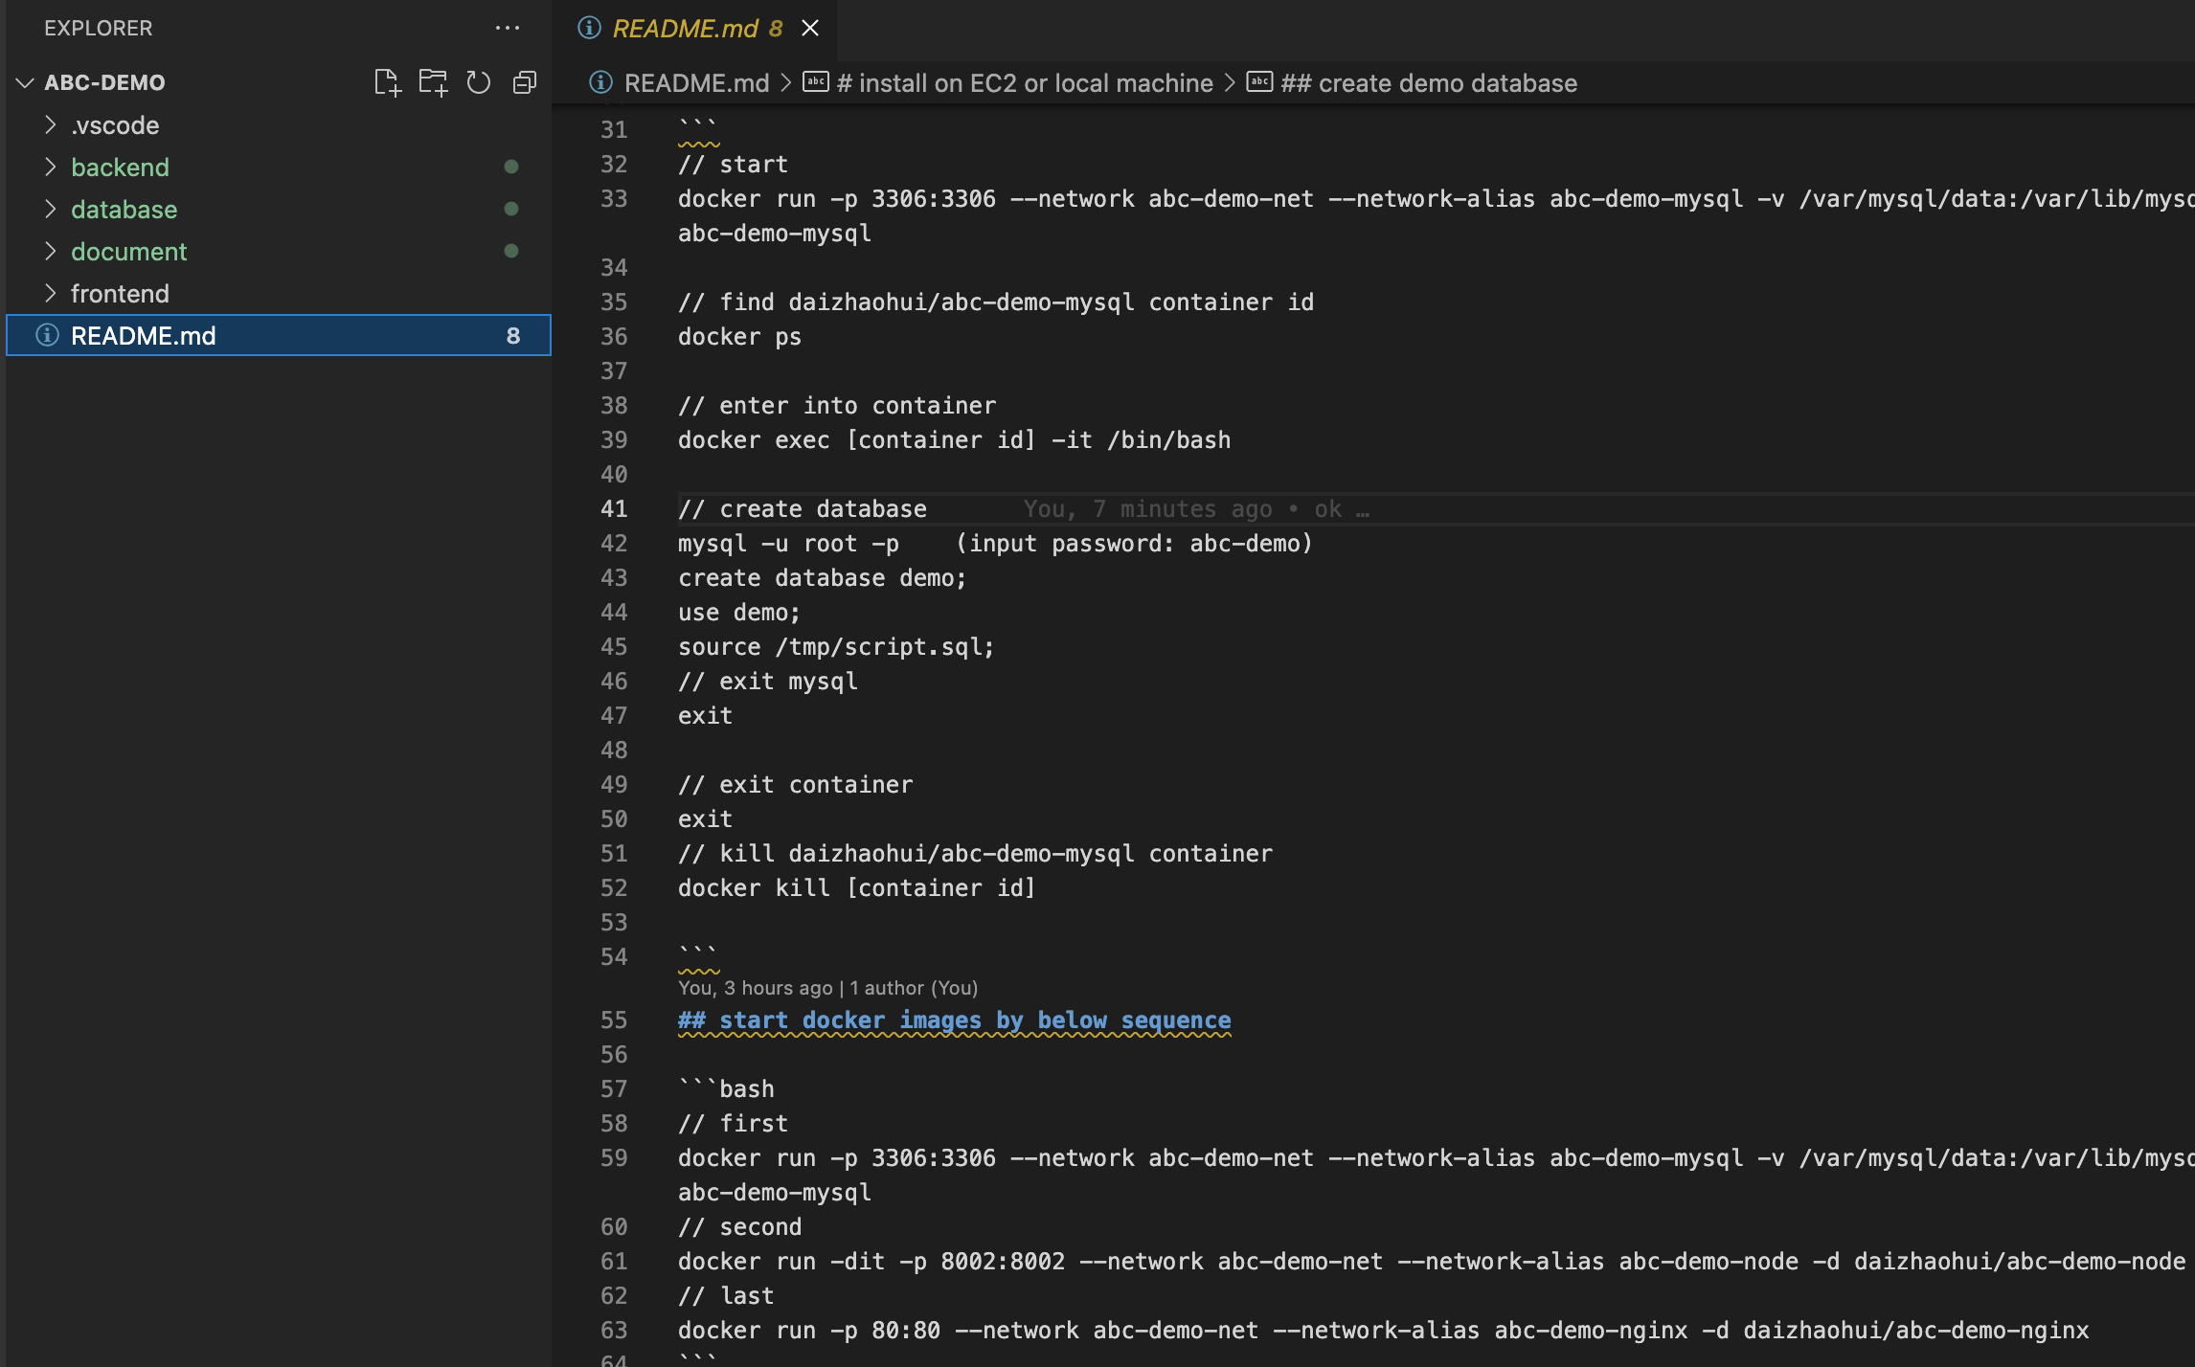

* Frontend

vue3+ typescript + jest

reference framework: <https://github.com/daizhaohui/lincy-vue>, <https://github.com/daizhaohui/lincy-js-utils>, <https://github.com/daizhaohui/lincy-docs>

* Backend

nest + typescript + typeorm + jest

* Databse

Mysql

* Deploy

docker,

|  |  |
| --- | --- |
|  | docker image address |
| Fronend | https://hub.docker.com/repository/docker/daizhaohui/abc-demo-nginx |
| Backend | https://hub.docker.com/repository/docker/daizhaohui/abc-demo-node |
| Database | https://hub.docker.com/repository/docker/daizhaohui/abc-demo-mysql |

1. demo screen shot

picture query

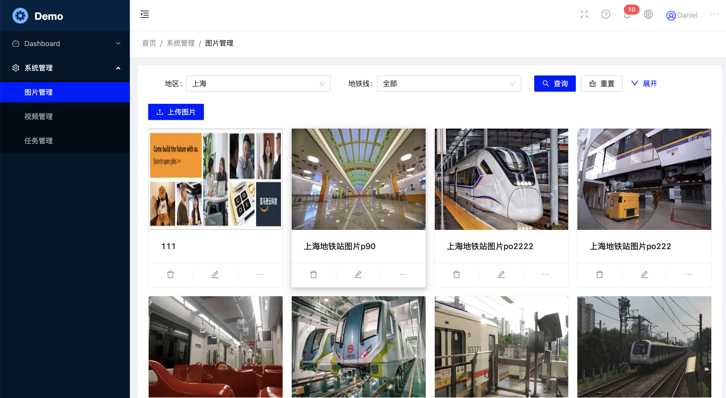

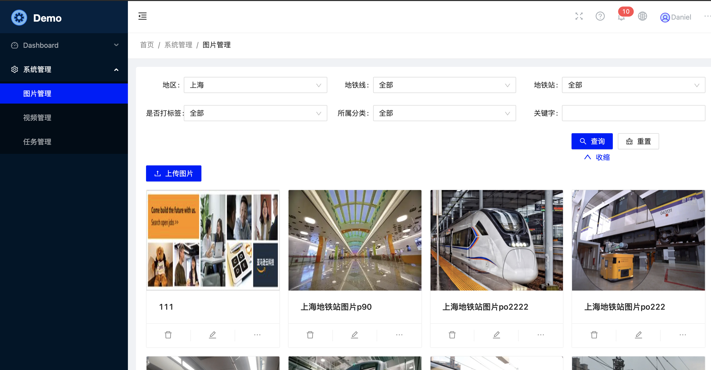

upload picture to S3

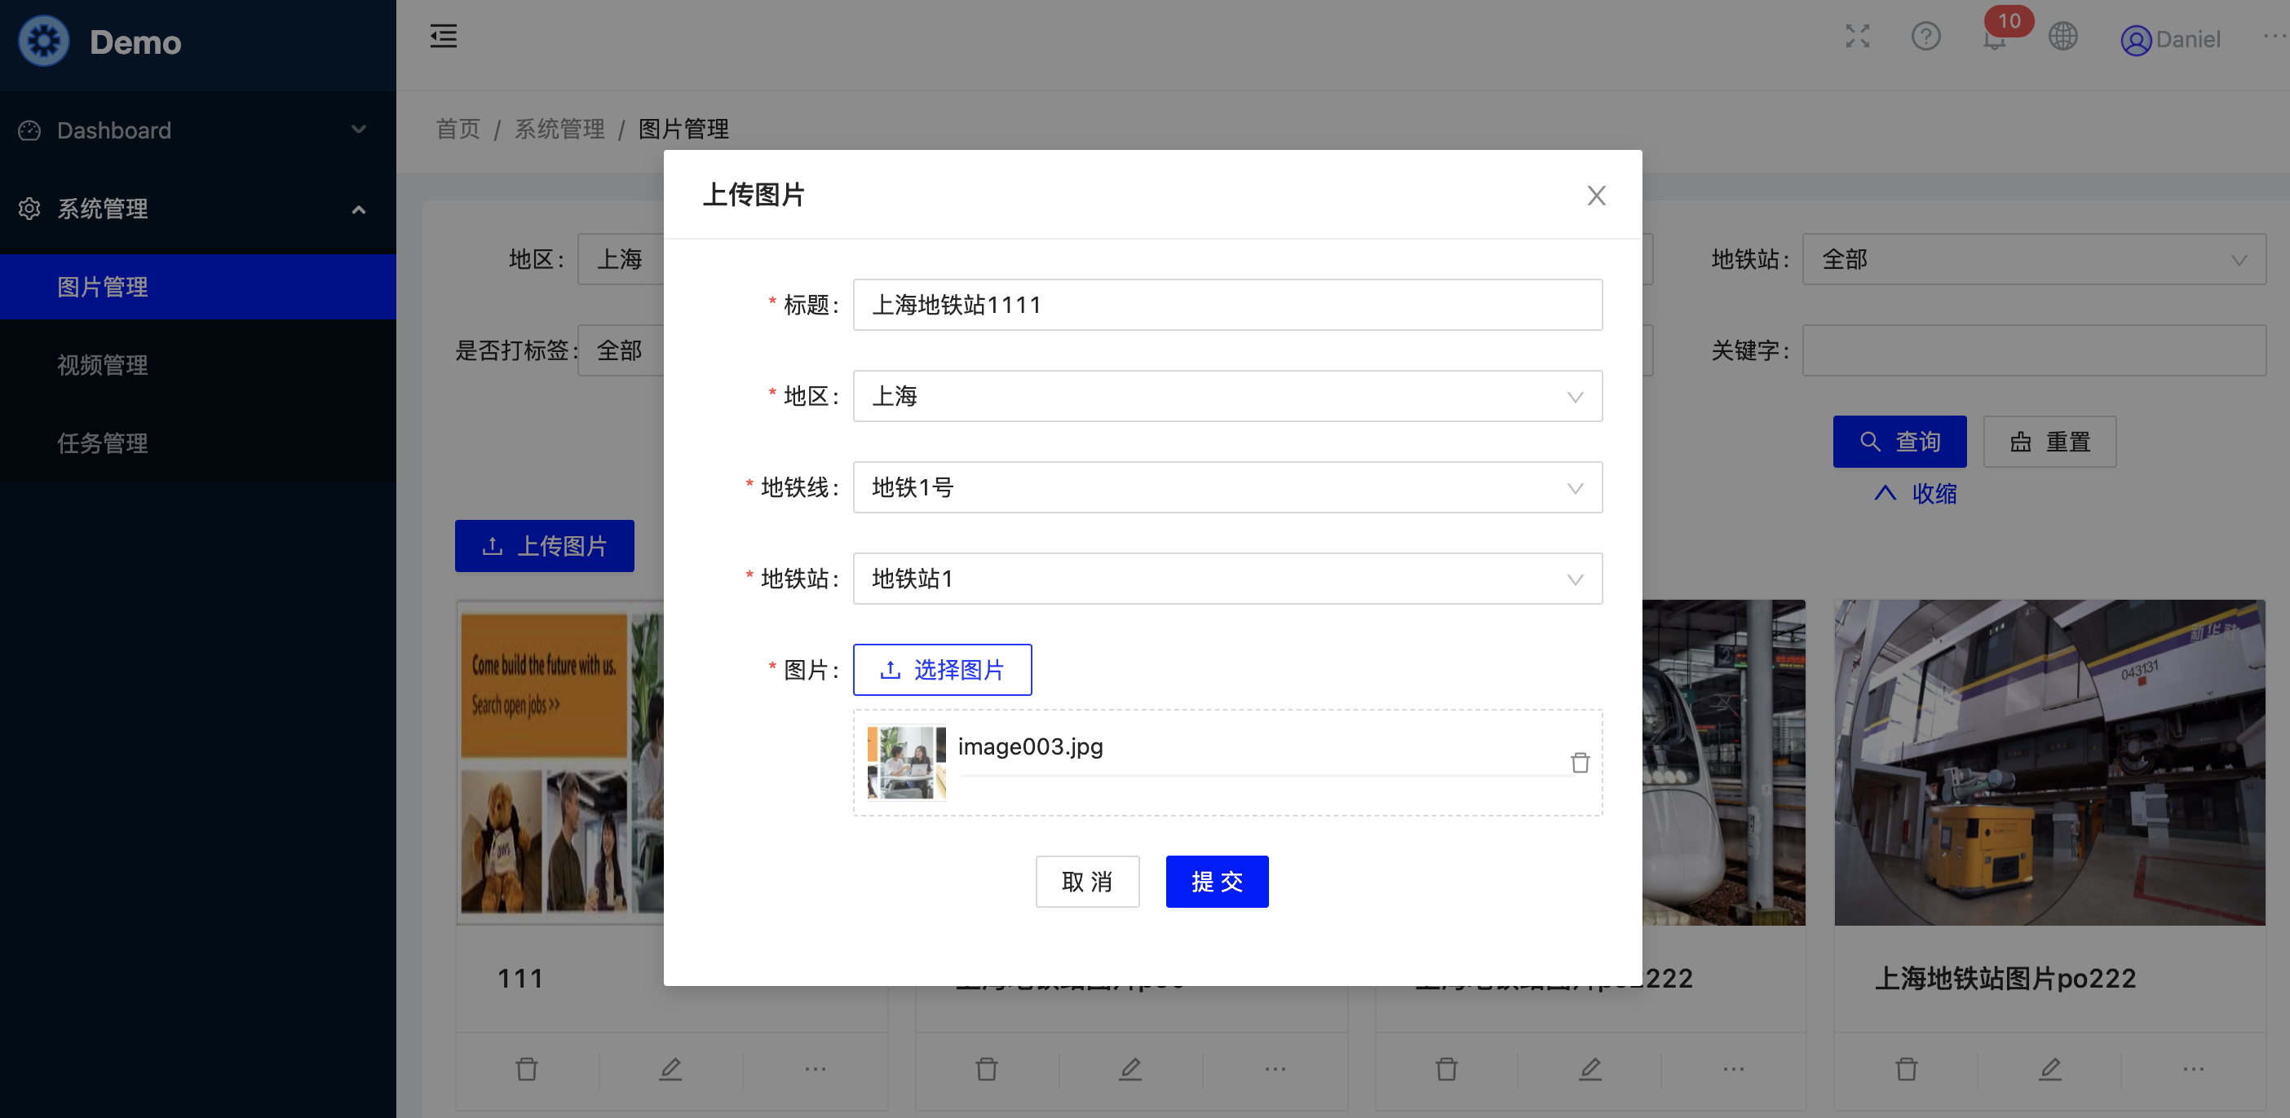

Label picture

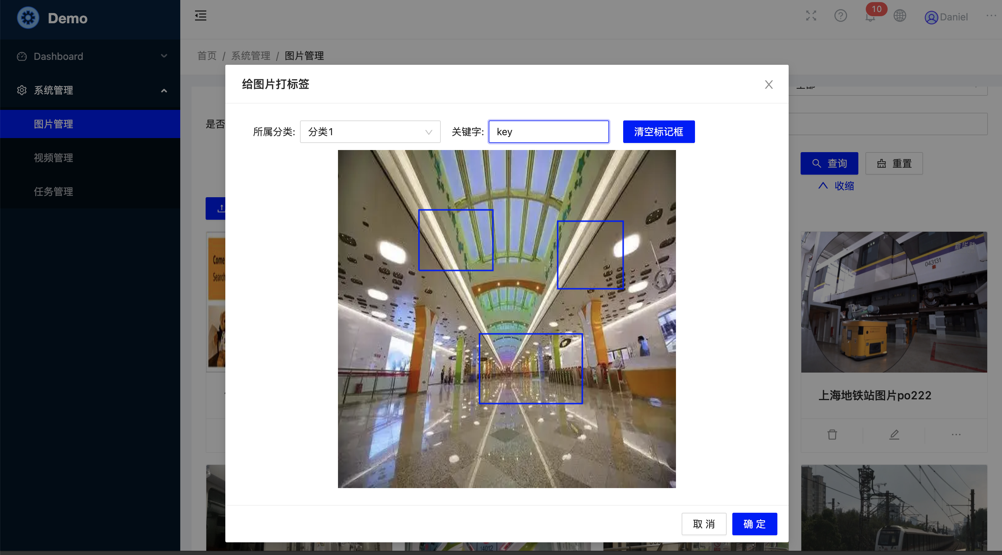

Video query

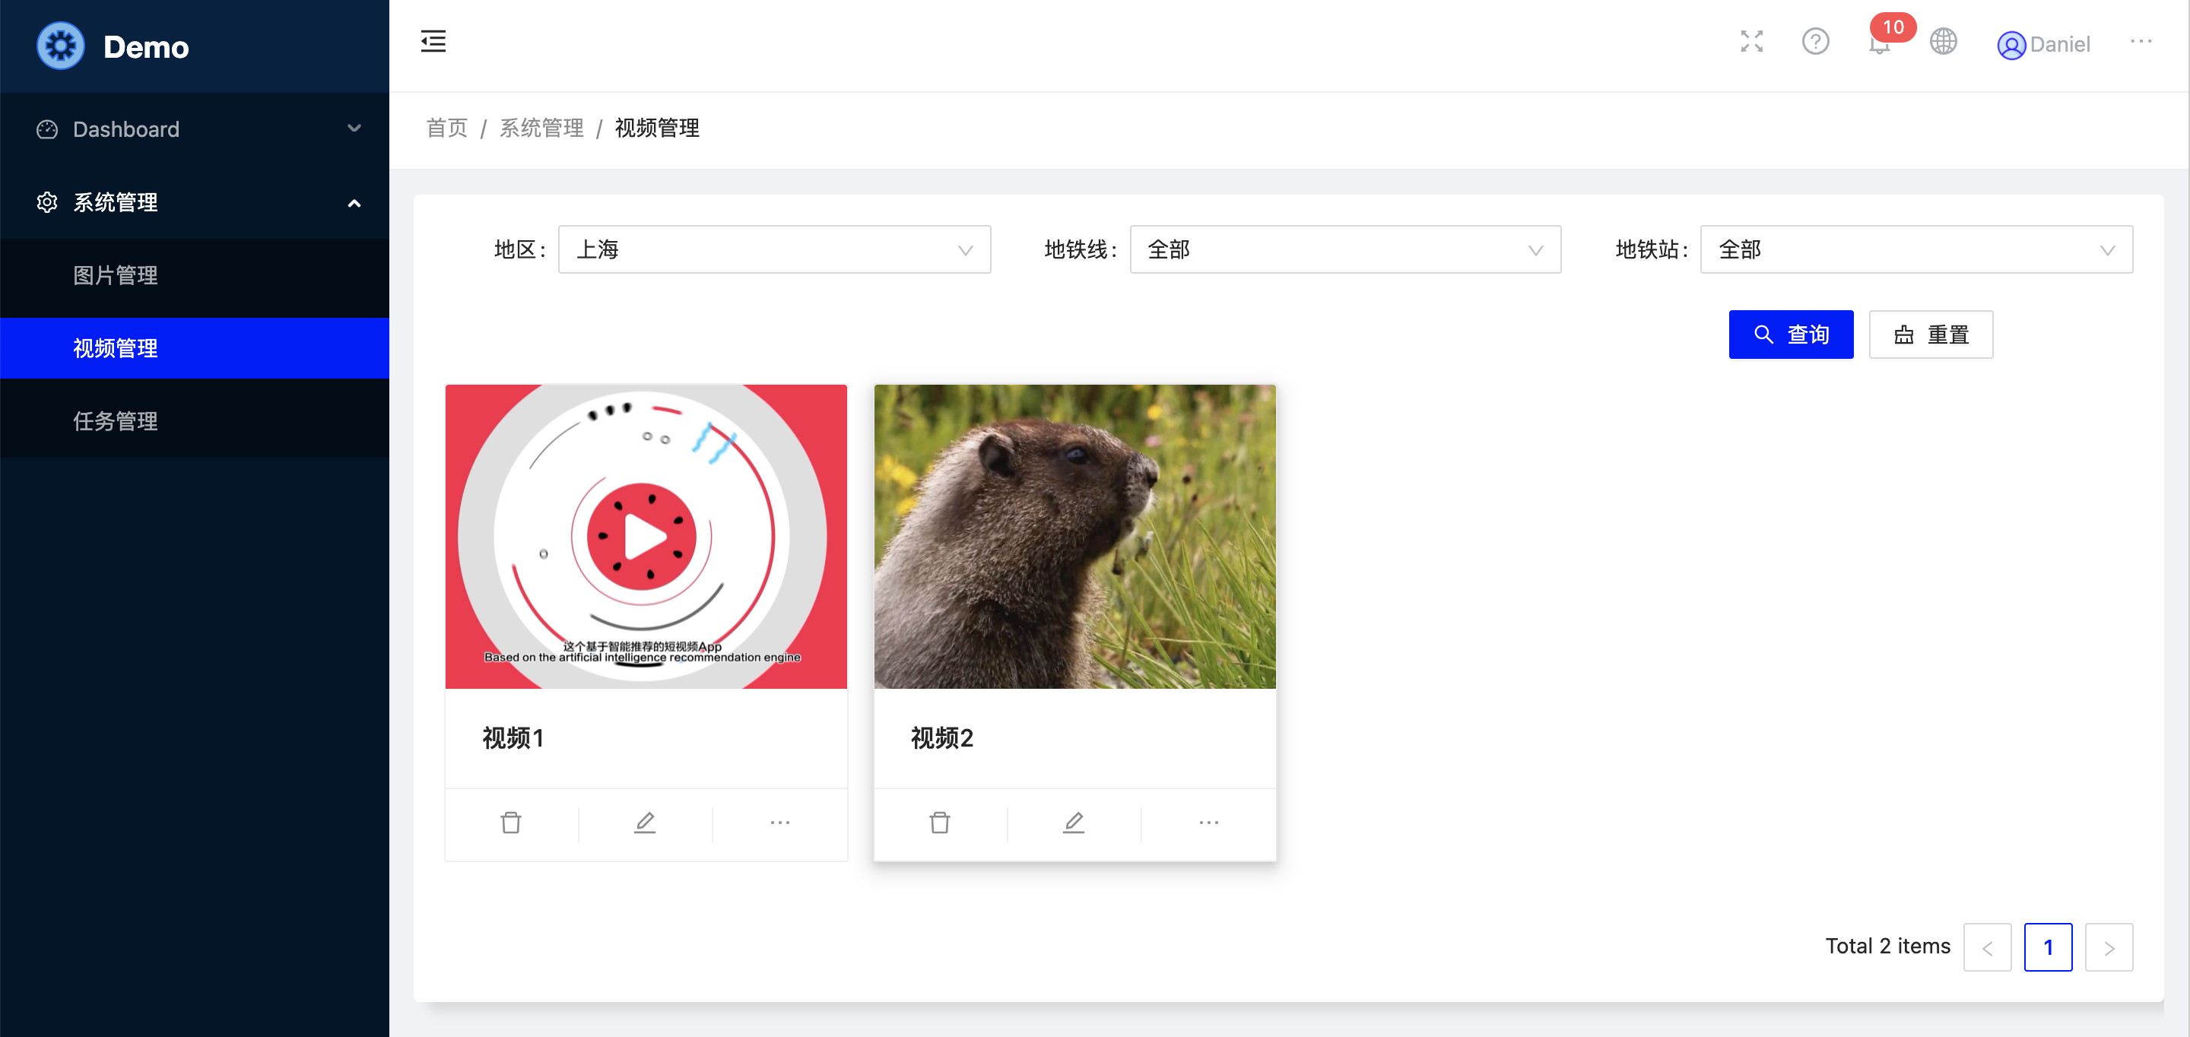

Paly video

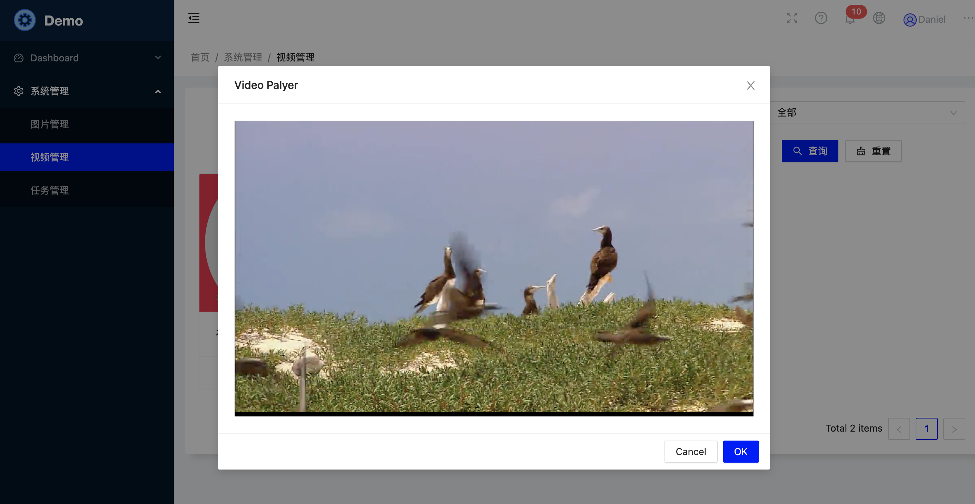

task status

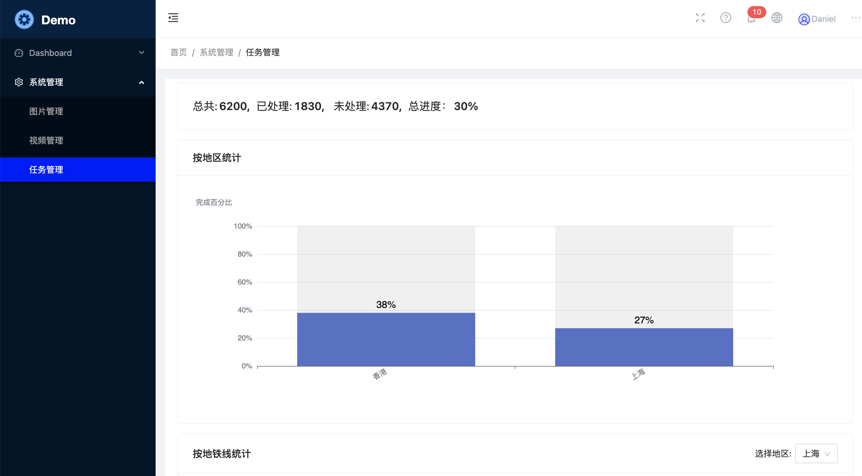

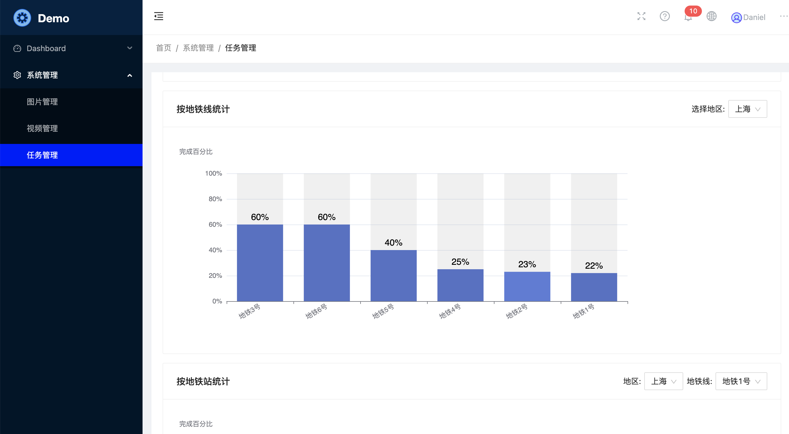

1. restfull api

The backend code project integrates the swagger document.

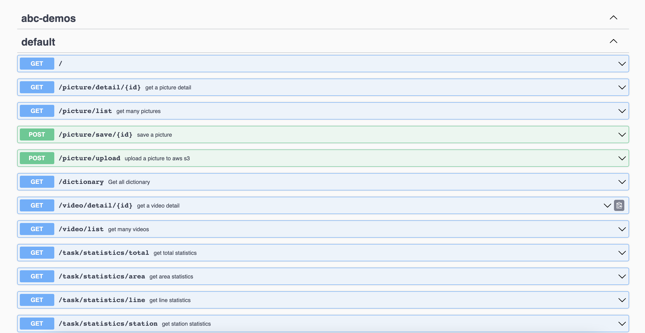

/picuture/upload api depends on the aws accouunt credential. My free personal account credential was configed. I am not sure that when it will

be invalid. Once my free credential is not valid, the api function will be available.

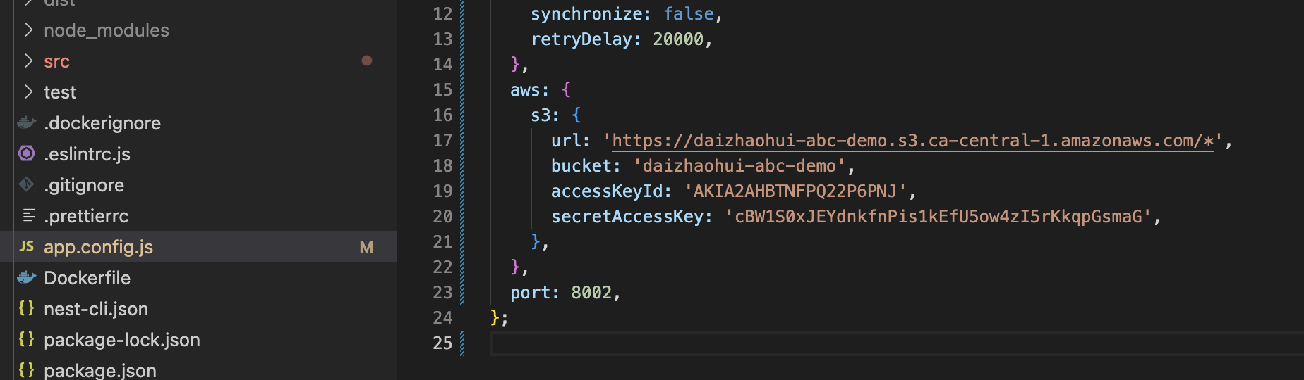

1. database (mysql)

I have put the database initialization script file named script.sql into the docker image. You can find it under directory ‘/tmp’. When you deploy database, you need to enter into docker container, connect mysql and execute the script file.

Your can also get database original data and the initialization script file from github website,<https://github.com/daizhaohui/abc-demo-data>

1. deploy

I suppose that you know docker commands when you want to deploy demo successfully. Good luck.